**VOLUNTEER AT CARWISE**

Field trips, Mentoring, Great American Teach In, Tutoring…...

WE NEED YOU!!!

Take a minute to register now so you don’t miss out!!!!You must be a registered volunteer to come on campus and go on field trips.

**New Volunteers-**Click this QR code to register!

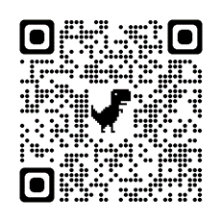

**Returning Volunteers *-* must reactivate using a computer, not mobile phone. Here’s the link-**

<https://focus.pcsb.org/volunteer>.

**Mentor -volunteers must take a mentor workshop to mentor a student. Here’s more information**-https://www.pcsb.org/mentor

**Thank you so much for your time!**

Emily Gleason

Family and Community Liaison

727-724-1442 ext. 2013

gleasone@pcsb.org